Orbital velocity and Gravitational force analysis of planets in solar system

Tony Liao – s4591339

Contents

1.Introduction 2

1.1 Project aims 2

1.12 Motivation 2

2 Data source 2

2.1 Data format 2

3. Data processing 3

3.1 Tools used for data processing 3

3.2 JSON Format Conversion 4

3.3 Data for multiple linear regression 4

3.31 Gravitational force of each planet 4

3.32 Relationship for each variable 4

3.4 Uniform unit for data 5

4. Data Analysis 5

4.1 Relationship between the planets and sun 5

4.2 3D visualisation planet surface textures 6

4.3 3D visualisation circular planes 7

5. Result 7

5.2 individual 3D visual for each planet’s orbiting velocity 7

6. Conclusion 9

# 1.Introduction

## Project aims

The aim of this project is to analyse and construct a unique visualization of orbital velocity of the inner and outer planets in the solar system. To achieve the aim of this project, the two main visualised techniques has been included:

* Multiple linear regression
* 3D visualisation

## 1.12 Motivation

## This project will incorporate a variety of visualizations with these datasets to provide a better understanding of the relationship of orbital velocity of planets between the distance from sun. It also utilizes quite complex interactive visualization which allows the audience to explore and interact with the data in real-time. The analysis of gravitational effects of planets can provide insight into how the solar system formed and how it continues to evolve over time. This project also can contribute to the broader scientific community's understanding of planetary dynamics.

# Data source

The data of the solar system can be found on the internet, I will primarily access the data from the NASA’s websites as they are appearing to be more reliable which data are gathered by certificated scientists with detailed information on the planets, including their mass, distance from the Sun, and other relevant parameters. I also have the capability to analyze individual objects using their respective public APIs. For example, to obtain data on a specific planet, the relevant API can be accessed to retrieve data on its gravitational effects, distance from the Sun, and other relevant parameters.

### 2.1 Data format

There are various data format that is used for recording the gravitational force or other relevant information for each planet. While considering the complexity of the data structures such as the properties of planets in solar system. JSON format is more suitable for representing this kind of nested or hierarchical data structures which is a lightweight, text-based format that is commonly used for data exchange between web applications and can be easily parsed and edited using programming languages such as Python. Thus, I will mainly use the data in JSON format to achieve these purposes.

JSON allows to store the properties of each planet in solar system. It has the collection of key value pairs of each property with key representing the name of planet and each associated value containing the properties such as mass, distance from sun and gravitational force.

A JSON Format that recorded the planet’s information:

{

"Mercury": {

"mass_10_to_power_24_kg": 0.33,

"orbital_period_days ": 87.969,

"surface_gravity": 3.7,

"distance_from_sun_10_to_power_6_km": 57.9

}

"Earth": {

"mass_10_to_power_24_kg": 5.97,

"orbital_period_days ": 365.2,

"surface_gravity": 9.8,

"distance_from_sun_10_to_power_6_km": 147.1

}

}

The code block that contained planet’s information is inside the {} with each key value pairs.

# 3. Data processing

## 3.1 Tools used for data processing

The tools that are been used for this project:

* VS code software is used for convert available data to JSON format.
* Matplotlib is a python library that handle for creating animated and interactive visualisations in this project.
* Python built-in package json is used to read the file in JSON format.
* Python scipy library, pandas library and statsmodels library are used for advance functionality to compute linear regression.
* Python ursina library is used for 3D visualisation for this project.
* Python Seaborn library is used for 2D visualisation for this project.

## 3.2 JSON Format Conversion

To convert the data to JSON format, I have collected the NASA’s planets fact sheet and save it to a text document and then paste the necessary data to VS code software in order to convert it to JSON format. Once it saved to text document, I removed the unwanted data and only kept the data which is useful for gravitational field such as mass and gravity. Then I converted it to JSON format by putting the associated values in VS code to edit it as collections of key pairs value and save the file extension as JSON.

## 3.3 Data for multiple linear regression

To accomplish the multiple linear regression, I used python’s linregress function from stats package in scipy library to generate the slope, standard error, residual and intercept of relevant data to compute the linear regression of the relationship between plants and sun.

### 3.31 Gravitational force of each planet

To generate the data of gravitational force between planets and sun in solar system, the json files is read using Python’s json package. To get the data of gravitational force, I have used the Newton’s law of universal gravitation formula:

Where is the target planet’s gravitational force, is the gravitational constant, is the distance from sun. To compare the relationship between planets in solar system and the sun, will be present as the mass of planets to be measured and will be the mass of sun. I then implemented a functionality in python to get all the result of gravitational force between planets and sun.

### 3.32 Relationship between each variable

Before going deeper for multiple linear regression model, it is better to understand the relationship between each variable in the data. To accomplish this, I first used python’s pairplot function from seaborn library to plot subplots for each individual relationship between gravitational force, velocity of planets and distance from sun.

Figure 1 The 2D plots of each relationship between orbital velocity of planets, gravitational force and distance from sun.

By doing this, I can clearly see that there might be some relations between each variables with labelled person’s correlation. There’s some plots appeared to have strong negative relationship such as the scatter plot for velocity of planets and the distance from sun.

## 3.4 Uniform unit for data

To accomplish the 3D visual for relationship of orbital velocity of plane and the distance from sun in a small screen. I assumed planet Mercury’s velocity 47.4km/s in 3 months rate per second, distance 57.9km (to the power of 6) from sun as 1km (to the power of 6) for its orbital and the circular plane to represent the area of orbit radius as 2.5km. By doing this, it will be more accurate to visualise it in 3D.

# 4. Data Analysis

## 4.1 Relationship between the planets and sun

The first visualisation was a 3D multiple linear regression that shows direct relationship between the velocity of planets, gravitational force of planets and distance from sun. With two independent variables velocity of planets, gravitation force of planets and one dependent variable distance from sun. In the scatter plot, The distance was too far and hard to keep it in a short range without scientific notation. I set the distance range between 0 – 5000 by set the unit to e+6 km so this can be representing as smaller number instead of very large number for each planet’s distance from the sun. By doing this, it is better to interpret the vary of velocity due to different distance from sun.

Figure 2 The 3D multiple linear regression of Relationship between orbital velocity and distance from sun

## 4.2 3D visualisation planet surface textures

To provide better visual, I used eight different colours for each planet in 3D visual to distinguish between eight different planets and the planes to represent their distance from sun. Unfortunately, there were planets such as Uranus and Neptune have very close colour range which are blue and cyan. Given by very little different with blue and cyan, it is hard to distinguish between them. To fix this, I have utilised the different textures of planets to distinguish the track of their orbit to the sun.

Figure 3 The eight surface textures for eight planets in solar system

This is an appropriate way to assists the audience with colour blind to identify the obvious texture for some planets where Uranus is not very obvious, and it is better for audience to identify each planet and planet’s distance from the differences of their surface texture.

## 4.3 3D visualisation circular planes

It is hard to visualise a planet’s more accurate distance from the sun as some planet could be very small hard to find its position. To tackle this problem, I have used eight circular plane indicated with each plane’s surface texture for better distinguish and use it to represent the area of each planet’s orbit.

# 5. Result

## 5.2 individual 3D visual for each planet’s orbiting velocity

The 3D visualization shows the positions of each planet with more accurate calculate distance scale and the circular plane represent for eight planet’s orbit area for better visual. Each planet’s velocity were animated by functionalities in Python ursina library. The velocity of planet increased depending on the distance from sun, the planet closer to the sun will have higher velocity than other planets and the planet further away from the sun will have lower velocity.

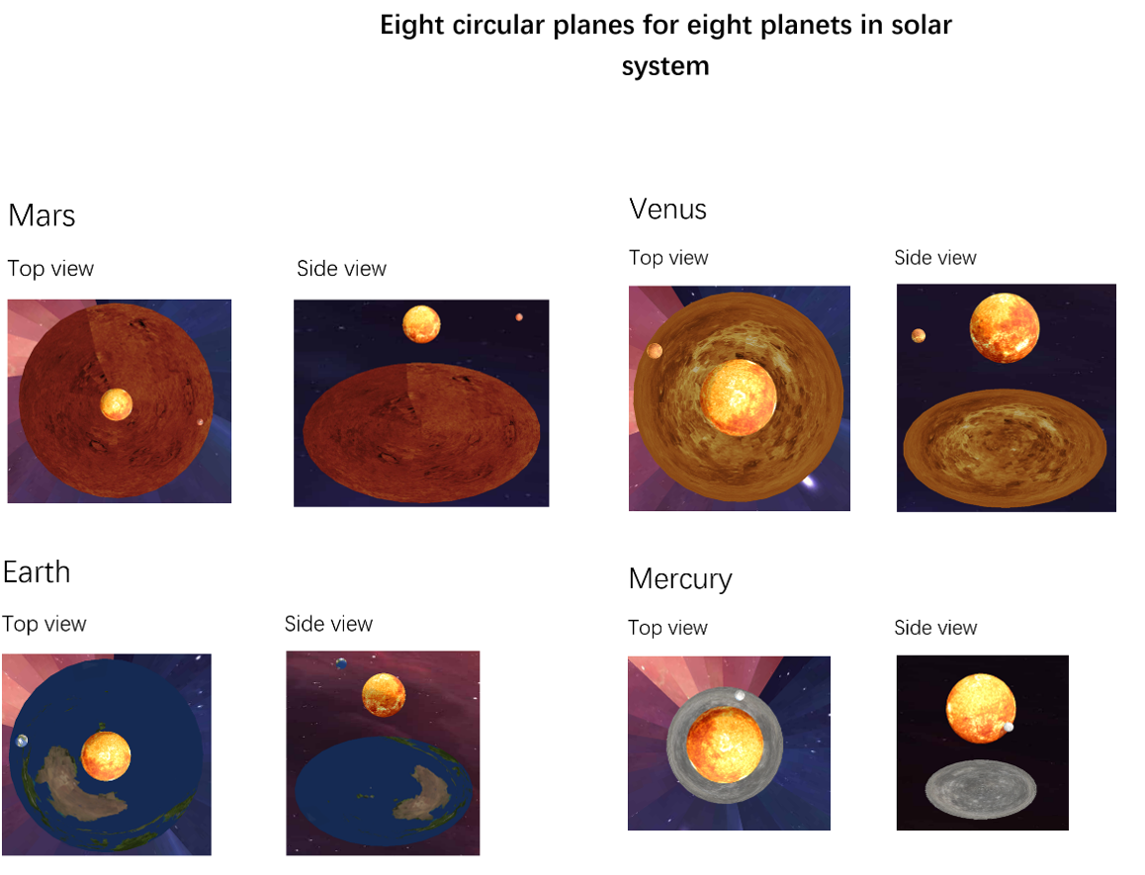

Figure 4 The individual 3D visualisation for each planet with corresponding circular planet in solar system

To visualise the relationship between velocity of planets and their distance from sun, I created the editor camera inside this 3D visual, this will become interactive for this visualisation and can have different camera view from different angles. This is shown in figure 3, it can have top view and side view by rotating the camera with mouse right button. It allows more comparison for this relationship with different view from any camera angles.

I have also add option for the user to choose whether they want to view eight planets individually or all together. By putting all planet’s together and their data of velocity and distance from sun into 3D visual, it surely will enhance their experience with this great visual in solar system.

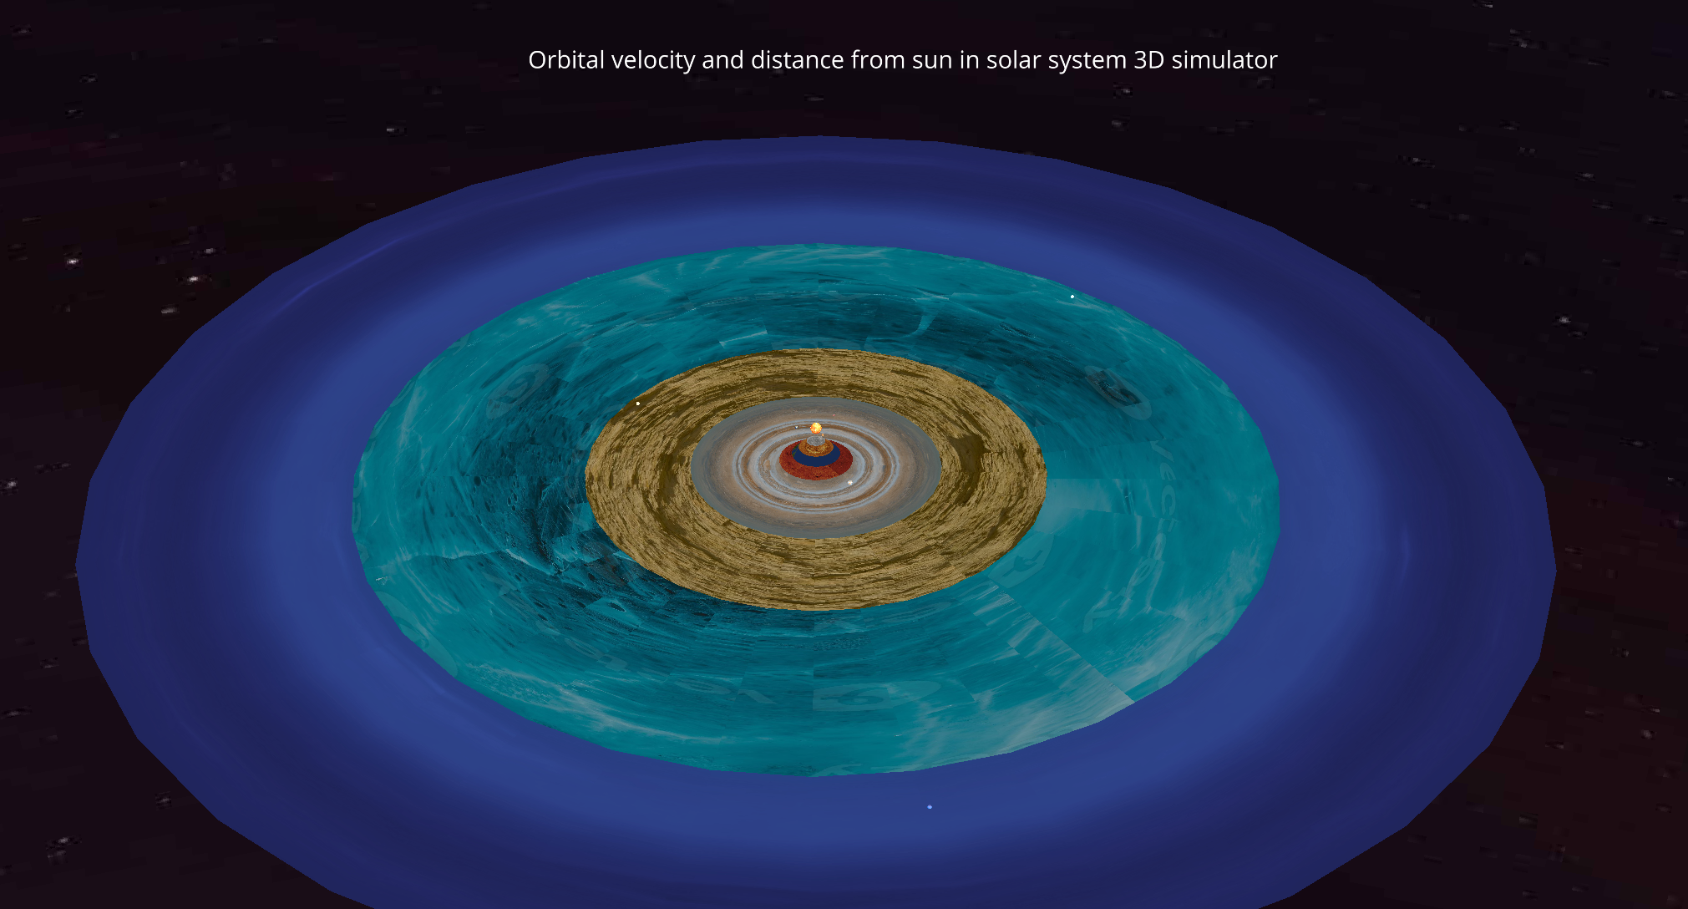

Figure 5 The full 3D visualisation for all eight planets with eight circular planets in solar system

# 6. Conclusion

Overall this project has successfully visualised an 3D visualisation with enhance interactive features for the velocity analysis of each planets in solar system and the relationship between velocity and the distance of each planets from sun.

With powerful python’s library ursina and matplotlib I was able to represent the great visual of 2D and 3D for this project.